Lecture #13 – DNA structure

References: Griffiths et al. 11th edition, Chapter 7

**Quizlet:** https://quizlet.com/_40ypsv

**Main Idea: DNA Structure**

**Key Words:**

1. Purine : a colorless crystalline compound with basic properties, forming uric acid on oxidation
2. Pyrimidine : a colourless crystalline compound with basic properties
3. DNA : Deoxyribonucelic Acid
4. Nucleotide : a compound consisting of a nucleoside linked to a phosphate group. Nucleotides form the basic structural unit of nucleic acids such as DNA.
5. Nucleoside : a compound (e.g. adenosine or cytidine) consisting of a purine or pyrimidine base linked to a sugar.

***Nitrogenous Bases:***

1. Adenine(A)
2. Guanine(G)
3. Cytosine( C )
4. Thymine(T)

***Nitrogenous Bases combined with ribose :***

1. Adenosine
2. Guanosine
3. Cytidine
4. Thymidine
5. 5’ and 3’ ends
6. Base pairs
7. Complementary : A goes with T (2 H bonds), G goes with C (3 H bonds)
8. Major groove : groove where the backbones are far apart
9. Minor groove : groove where the backbones are close together
10. Chromatin : the material of which the chromosomes of organisms other than bacteria (i.e. eukaryotes) are composed, consisting of protein, RNA, and DNA.
11. Histones : any of a group of basic proteins found in chromatin (usually 8 balls and 1 rod)
12. Nucleosome : a structural unit of a eukaryotic chromosome, consisting of a length of DNA coiled around a core of histones
13. Supercoiling form (a substance) into a superhelix

**Take Home Messages :**

* DNA is the genetic material of all living organisms (some viruses use RNA)
* DNA is a polymer made up of nucleotides
  + These nucleotides are heald together by phosphodiesrer bonds
* Each nucleotide contains a *base* (A, C, G, T), a *2’ deoxyribose sugar*, and a *phosphate*
* DNA consists of two, anti-parallel polynucleotide chains (parallel and anti-parallel strands of DNA)
  + Together they associate together via base pairs to form a right handed helix
* Base pairing follows strict rules:
  + A(purine) pairs with T(pyrimidine) via 2 H bonds
  + G(purine) pairs with C(Pyrimidine) via 3 H bonds
* The Watson-Crick model of DNA nicely explains all the characteristics of the genetic material
* DNA must be packed into higher order structures to fit into cells

**Key Images (Not in Script):**

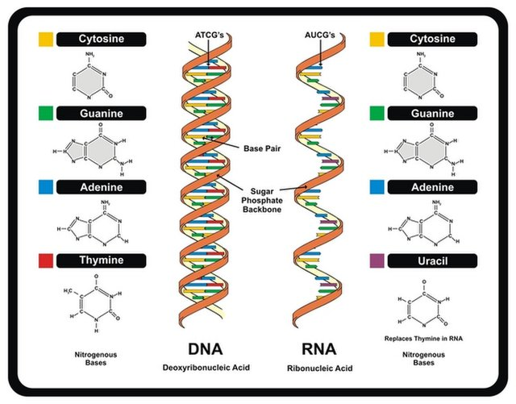

**Script:**